[ 2CEIT5PE18:MOBILEAPPLICATIONDEVELOPMENT]

Practical: 8

AIM-Create
your
first
Hello
World
iOS
app
in
SwiftUI
Submitted By: HAJI MOHAMMADALI
Enrollment number: 23012011019


Department of Computer
Engineering/Information Technology
Practical-8
- Create a new iOS app by selecting File -> New -> Project… from the Xcode menu. Choose the App template from the Application section in the iOS tab.
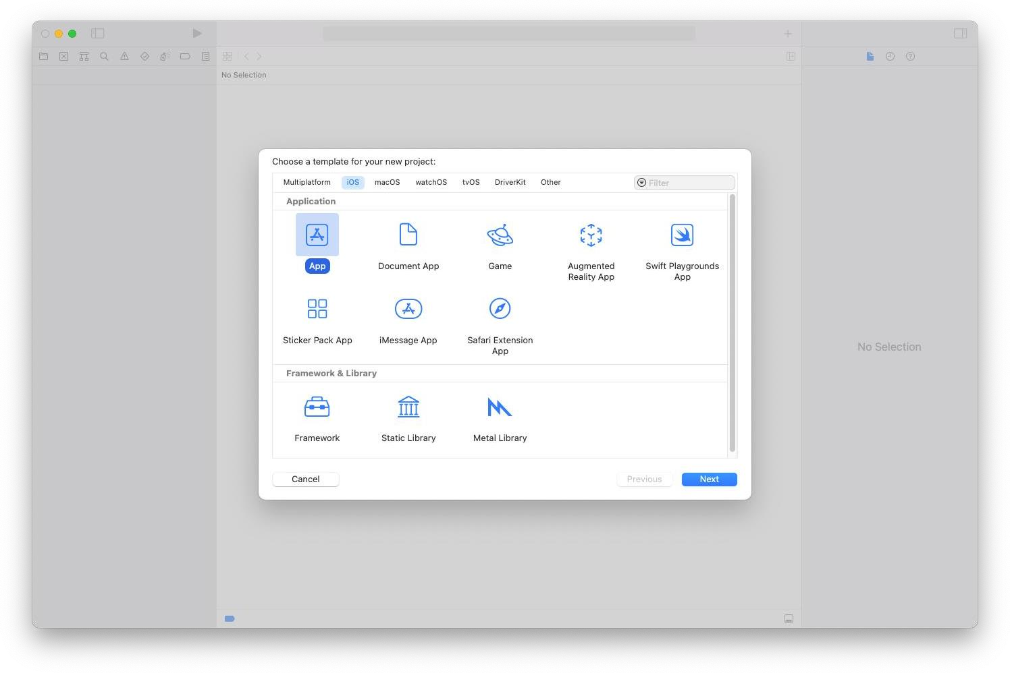
  - Name the app hello world.
  - Xcode uses name to set the bundle identifier for the app.
  - Select SwiftUI for the technology used to build the app’s user interface. (d) Set Swift for the programming language used to code the app.
  - Ensure that the Core Data and unit testing options are not selected. You don’t need local databases to store the app’s data since it’s elementary. There is also no need to test the code of such a basic app.
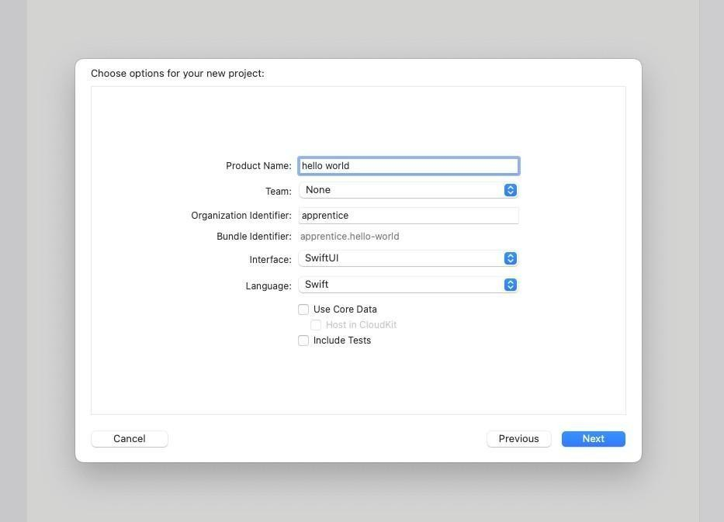
  - Finally, check the Create Git repository on my Mac for your project and save it. It’s useful to initialize a Git repository for any project you create since you will likely need it
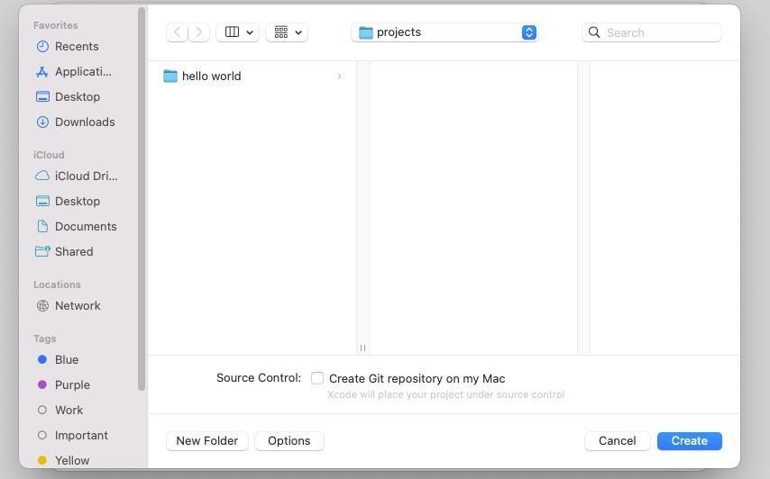
- Understanding the structure of a basic SwiftUI iOS app
    - The hello world project has two source code files. You can choose either one of them from the project navigator on the left side of the Xcode editor.
    - Open the hello_worldApp.swift file and take a look at the code.
import SwiftUI
@main
struct hello_worldApp: App
{ var body: some Scene { WindowGroup {
ContentView()
}
}
}
    - The most important thing you should be aware of is that you are using a structure, which is a custom Swift data type, to define the main scene of the app. The scene handles a group of views of the app. There
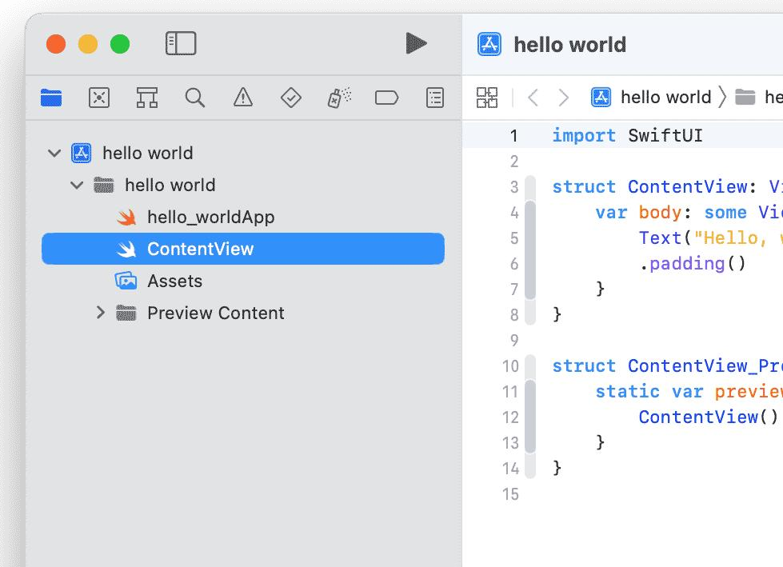
is only one view, in this case, declared in the ContentView.swift file.
Open the ContentView.swift file. And take a look the code:
struct ContentView: View
{ var body: some View {
Text("Hello, world!")
.padding()
}
}
(3) Run your first iOS app in the simulator.
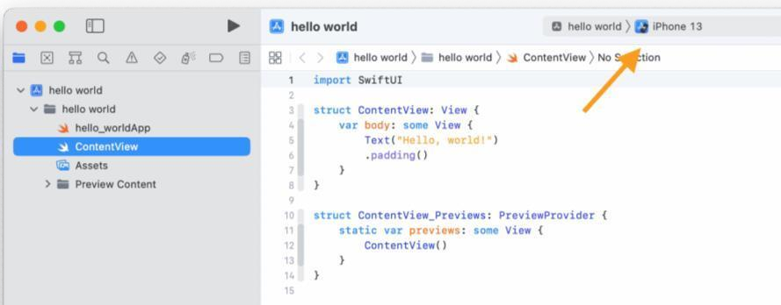
You don’t need an iPhone to run basic apps. A simulator has all of the essential features of an actual device, and it is much easier to run an app using this.
- The first step is to choose the iOS simulator that you want to run the app on. A default simulator is already selected at the top of your Xcode project window.
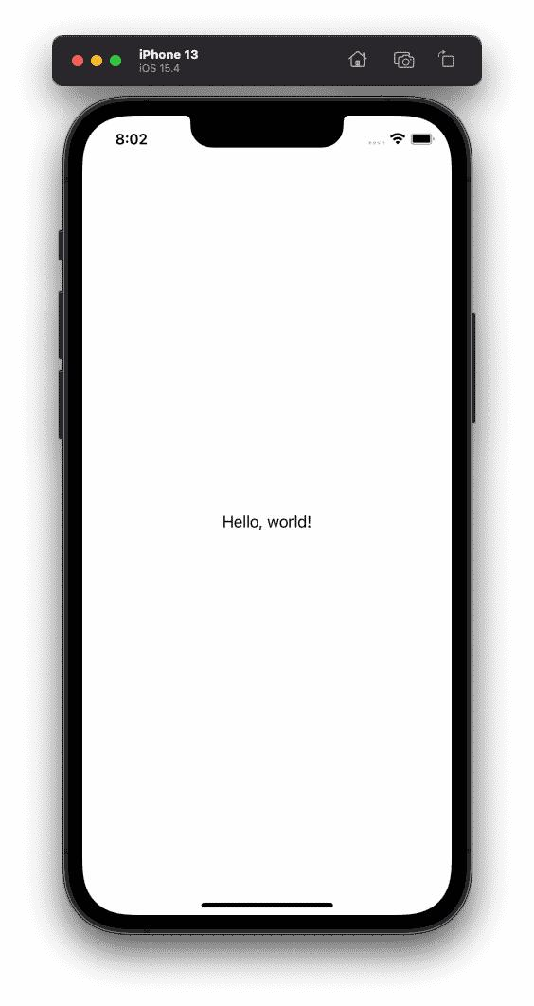
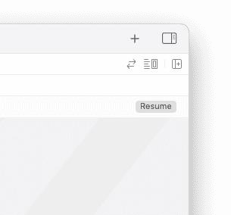
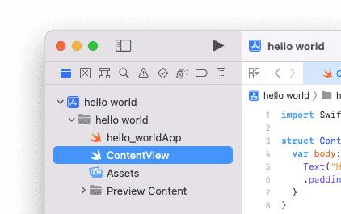
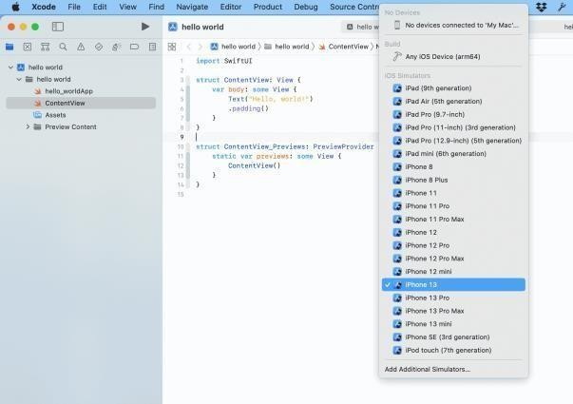
- You can click on the default simulator and choose a custom one from the simulator menu that appears.
The
project
builds
itself
without
errors
and
then
runs
the
app
on
the
chosen
simulator
•
SwiftUI
also
allows
you
to
preview
the
app
’
s
appearance
without
running
the
app
on
a
simulator.
To
do
this,
switch
to
the
ContentView.swift
file
and
look
at
the
preview
code.
struct
ContentView_Previews:
PreviewProvider
{
static
var
previews:
some
View
{
ContentView()
}
}
•
The
code
creates
a
structure
that
handles
the
updates
of
the
app
’
s
main
view
to
preview
them.
You
can
press
the
resume
button
at
the
top
right
of
the
preview
window
to
preview
the
changes
The
preview
simulator
is
perfectly
synchronized
with
the
code
of
the
view.
This
means
that
any
changes
you
make
to
the
code
in
the
left
panel
can
be
seen
in
the
simulator
in
the
right
panel
immediately.
(
c
)
Press
the
play
button
at
the
top
left
of
the
project
window
to
run
the
app.
